American International University-Bangladesh (AIUB)


Department of Computer Science
Faculty of Science and Technology

Student Details
Student Name |  | Student ID | Contributed Topic | Percentage%
Topic Name :
Outdoor Sports Management System

Submission Date:23.08.2025
TABLE OF CONTENTS

- INTRODUCTION:
The Outdoor Sports Management System is a comprehensive platform built to simplify the management of sports facilities, enhance player experience, and streamline event coordination. Designed for both sports organizations and individual players, this system empowers users to easily book turfs, create and manage teams, schedule matches, and view their profile all from a single, user-friendly interface.
The Home Page serves as a gateway to the platform’s core features, providing easy navigation for users to Join, Create a Team, or Book Turf. The design is clean and intuitive, ensuring easy access for players and administrators to the tools they need.
Key Features:
- Turf Management: Players can view available turfs and book them for matches or practice sessions. The Turf View feature allows users to explore the turf in detail before making a booking.
- Team Creation & Management: Players can form or join teams easily. The platform allows team creation, member invitations, and roster management. Teams can view available slots and schedule practice sessions or matches.
- Booking & Payment: The Booking Summary page provides players with an overview of their upcoming bookings. The Payment Options and Payment Success pages offer secure and smooth transaction processing, with multiple payment methods available for flexibility.
- Event Scheduling: Organize and manage sports events like tournaments and matches effortlessly. The Booking Summary page keeps players and administrators updated with event schedules and details.
- Profile Management: Users can manage their personal information and track their activities, including match history and performance.
- Favorites: Users can save their favorite turfs and bookings for quick access in the future, enhancing their experience with easy links to frequently used services.
The system integrates Nest.js for backend efficiency, Next.js for a responsive and dynamic frontend, and a secure SQL/PLSQL database for robust data management. The platform ensures real-time updates, reliability, and scalability to meet growing user needs.
By using this platform, sports organizations can efficiently manage their grounds, schedules, and player data, while players enjoy a seamless and engaging sports experience whether they’re booking a turf for practice, forming a team, or participating in a match.

- PROJECT PROPOSAL :
Project Overview:
The Outdoor Sports Management System is a comprehensive, user-friendly platform designed to simplify the management of sports facilities, enhance player experience, and streamline event coordination. This platform will serve both sports organizations and individual players, allowing users to easily book turfs, create teams, manage events, and access their profiles all from a single interface.
With a clean and intuitive design, the system enables players to view real-time turf availability, reserve slots for practice or matches, and manage team activities. Sports organizations will benefit from the efficient management of turf bookings, player data, and event scheduling.
Objective:
The primary goal of the Outdoor Sports Management System is to provide a seamless and efficient solution for managing outdoor sports activities. The system will achieve this by:
- Allowing players to easily book available turfs for matches or practice sessions.
- Enabling players to create and join teams, as well as manage team schedules.
- Providing administrators and sports organizations with tools to manage turf availability, player data, bookings, and payments.
- Offering a secure and smooth payment gateway for all bookings and event participation.
Scope of the Project:
- Target Audience:
  - Sports Organizations: Clubs, event organizers, coaches, and administrators who need an efficient platform to manage turf availability, player data, and event schedules.
  - Players: Individuals who want to easily book turfs, participate in events, form or join teams, and manage their profiles.
- Key Features:
  - Turf Management: Players can view available turfs, check their condition, and book them for practice or matches. The Turf View feature allows users to explore turfs before making bookings.
  - Team Creation & Management: Players can create or join teams, invite members, and manage rosters. Teams can view available slots and schedule practice sessions or matches.
  - Booking & Payment System: The Booking Summary page provides players with an overview of upcoming bookings. The Payment Options and Payment Success pages ensure secure transactions, with multiple payment methods available.
  - Event Scheduling: Admins and players can organize sports events such as tournaments and matches. The system automatically updates players with event details and schedules.
  - Profile Management: Users can update their profiles, view team participation, and manage personal information.
  - Favorites: Players can save their favorite turfs and bookings for easy future access.
- Technology Stack:
  - Frontend: Next.js for a dynamic and responsive user interface.
  - Backend: Nest.js for handling backend logic and managing API requests.
  - Database: SQL/PLSQL for secure, scalable data management.
  - Payment Integration: bKash, Nagad, or other payment gateways for secure and smooth transactions.
Problem Statement:
Currently, sports organizations and players face challenges in managing turf bookings, organizing events, and tracking player data manually. This often leads to inefficiencies, double bookings, and poor communication. Players also struggle to find and join teams that match their skill levels, and administrators face difficulties managing large amounts of data.
Proposed Solution:
The Outdoor Sports Management System addresses these challenges by:
- Providing a platform where users can check turf availability and book slots in real-time.
- Allowing players to create or join teams, view team rosters, and schedule events or practices.
- Offering a smooth and secure payment system for booking turfs and registering for events.
- Allowing administrators to manage events, bookings, player data, and payments with ease.

Expected Outcomes:
- For Sports Organizations:
  - Simplified turf and event management.
  - Enhanced communication with players and teams.
  - Reduced administrative workload and errors.
- For Players:
  - Easy access to turf availability and event schedules.
  - Streamlined team creation and participation.
  - Personalized experience with player profiles and team management.
Timeline:
The project will be completed in the following phases:
- Phase 1: Planning & Requirements Gathering (1 weeks)
- Phase 2: System Design & Database Schema (2 weeks)
- Phase 3: Backend & Frontend Development (3 weeks)
- Phase 4: Integration & Testing (1 weeks)
- Phase 5: Deployment & Final Review (1 weeks)
Budget & Resources
The project requires resources for:
- Software tools and technology (Next.js, Nest.js, SQL/PLSQL).
- Web hosting and domain registration.
- Payment gateway integration.
- Development and testing resources.
The estimated budget will cover these resources, with the project expected to be completed over the course of 2 months.

- User Interface: (Figma)
Figma Live link:
https://www.figma.com/design/gu6MmmA9LLIFNvthsJOYzK/Outdoor-sports-management?node-id=0-1&p=f&t=R19DcoDAKIZGseXV-0
 | 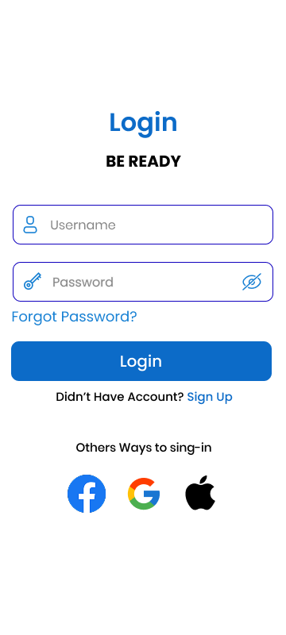
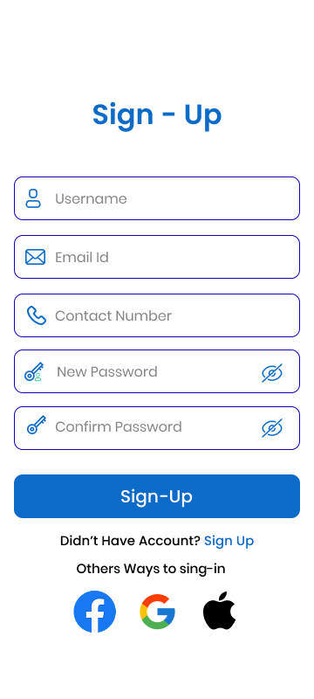 | 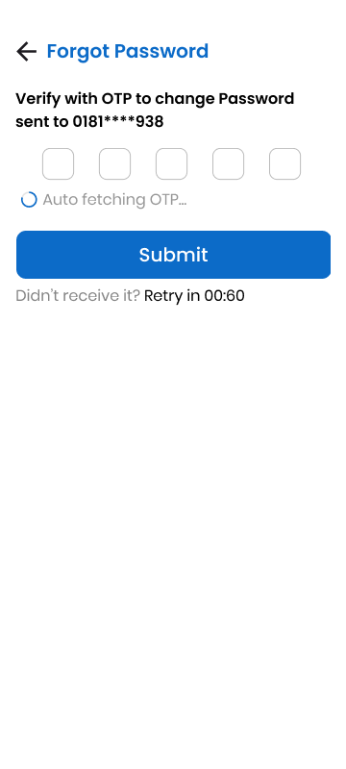
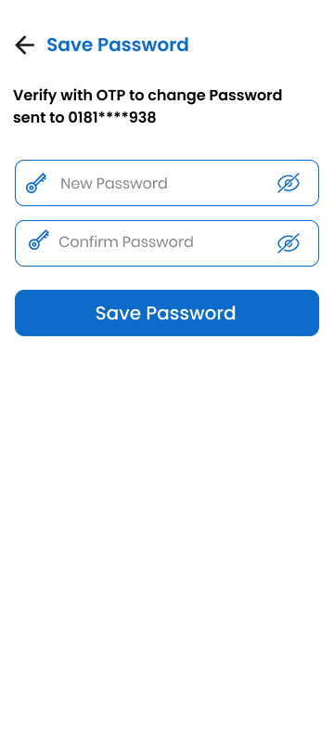 | 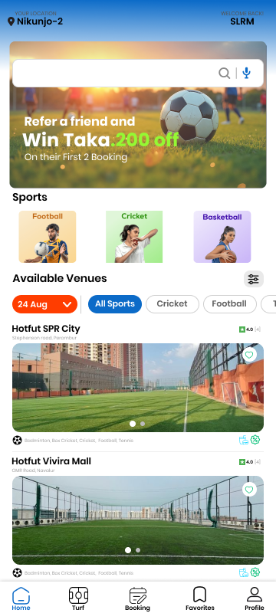
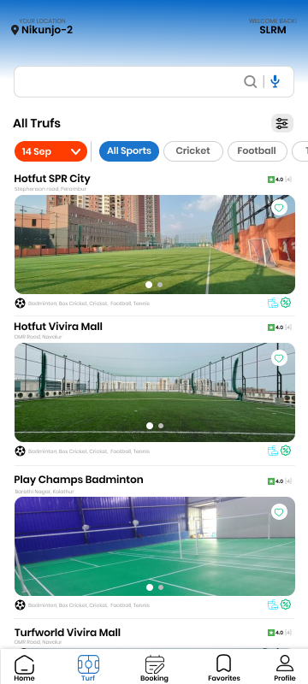 | 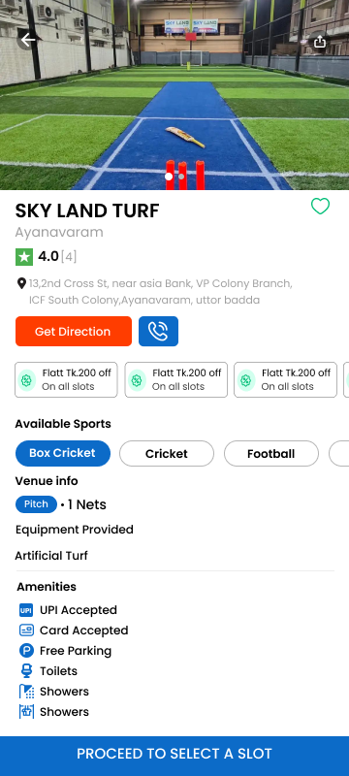
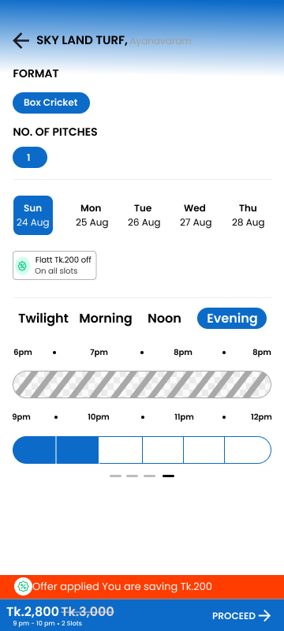 | 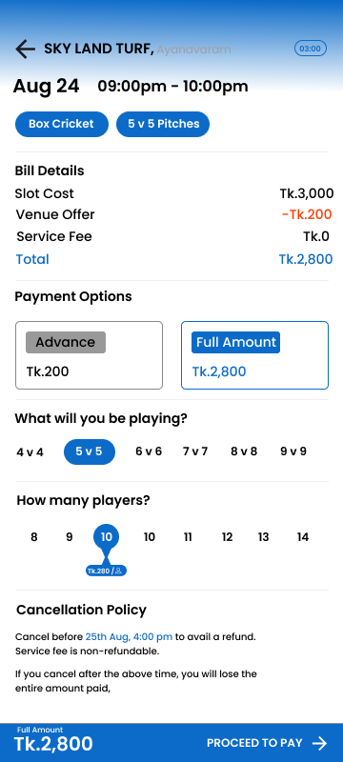
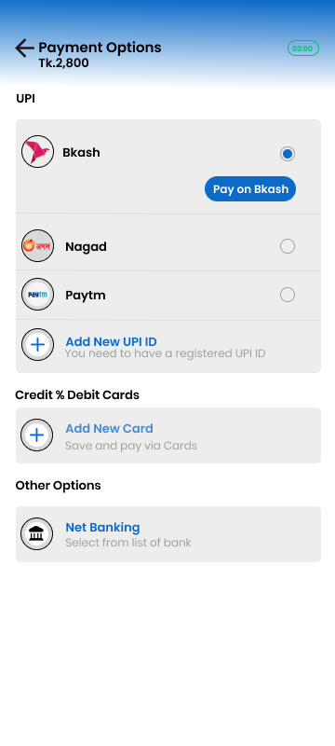 | 
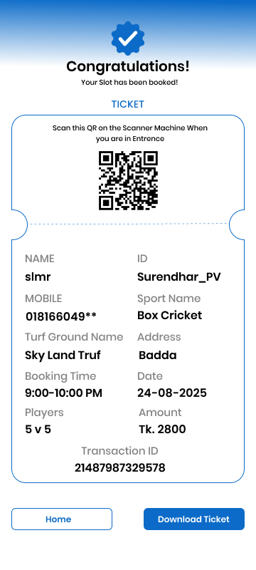 | 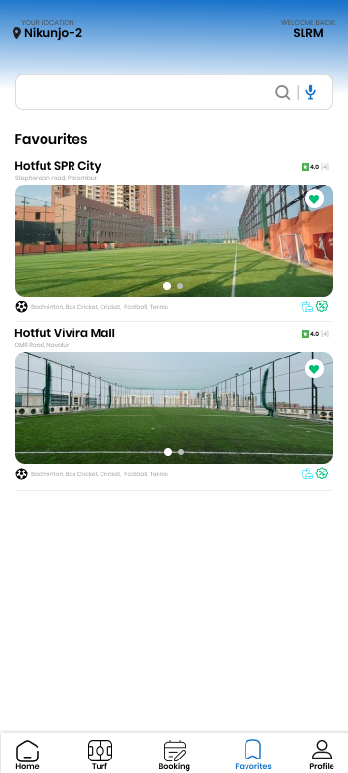
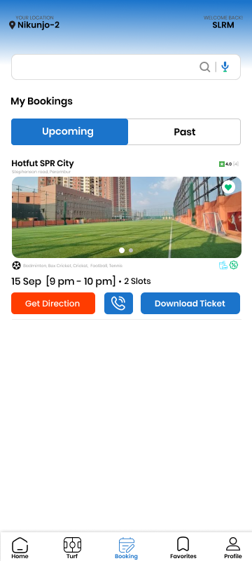 | 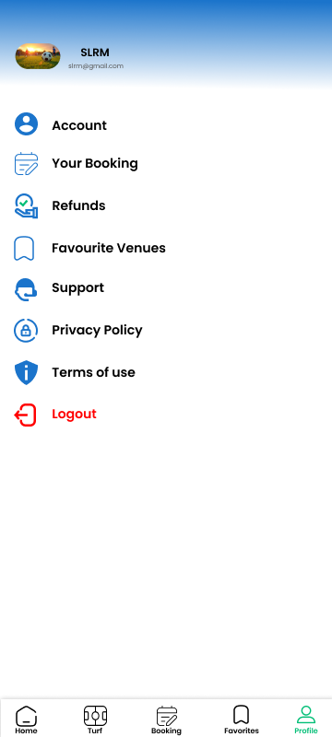

- SCENARIO DESCRIPTION:
In an Outdoor Sports Management System, one Player can belong to only one Team. Each Player has a unique identification number (Player ID), Name, Date of Birth, and Phone Number. A Name is composed of First Name and Last Name.
Each Player has one Profile. A Profile has a unique identification number (Profile ID), Skill Level, and a record of Achievements.
One Team can make many Bookings, and one Booking is made by one Team. A Team has a unique identification number (Team ID), Team Name, and Sport Type.
One Player can also make many Bookings, and one Booking is made by one Player. A Booking has a unique identification number (Booking ID), Date, Start Time, End Time, and Status.
One Turf can be booked for many Bookings (at different times). A Turf has a unique identification number (Turf ID), Name, Location, Size, and Type (e.g., Grass, AstroTurf).
One Event requires one Turf, but one Turf can host many Events. An Event has a unique identification number (Event ID), Name, Date, and Rules.
Many Teams can participate in one Event, but for this system, we will model it as many Teams participating in one Event. An Event's details include its participating Teams.
One Staff Member manages many Events and also manages many Bookings. Each Staff Member has a unique identification number (Staff ID), Name, and Department. A Name is composed of First Name and Last Name.
One Booking can be paid for by many Payments (e.g., installment plans, multiple payment methods). A Payment has a unique identification number (Payment ID), Amount, and Payment Date.
Many Payments can be processed by one Staff Member. Each Payment is associated with one Payment Type (e.g., Credit Card, Debit Card, Cash). Each Payment Type has a unique code (Payment Type Code), a Payment Method, and a Description.

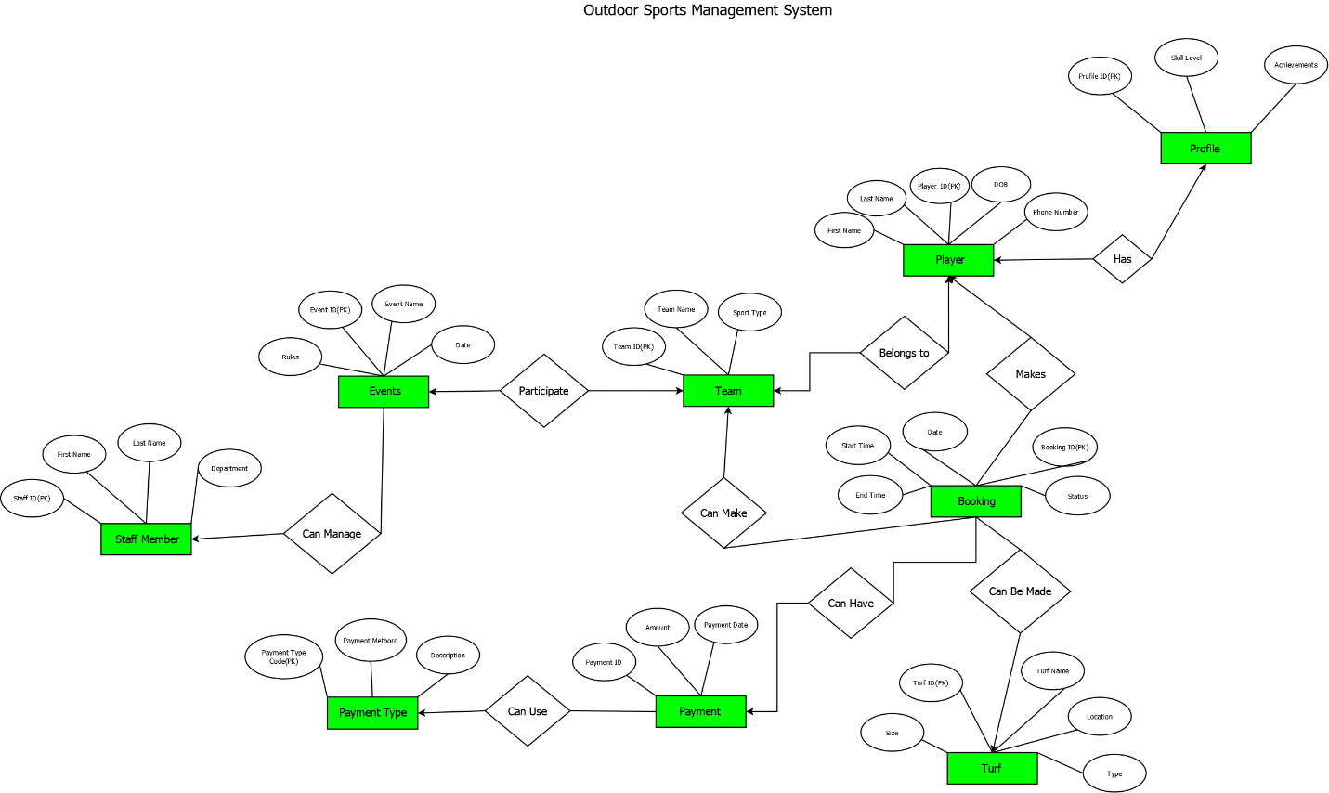
- ER DIAGRAM:

Fig-1: ER diagram

- NORMALIZATION:
Relation 1: Can Manage (Staff Member Can Manage Event)
UNF:
Can_Manage(Staff_ID, First_Name, Last_Name, Department, Event_ID, Event_Name, Date, Rules)
1NF:
No multivalued attributes, so it remains
1. Staff_ID, First_Name, Last_Name, Department, Event_ID, Event_Name, Date, Rules

2NF:
Staff details depend on Staff_ID
Event details depend on Event_ID.
1. Staff_ID, First_Name, Last_Name, Department
2. Event_ID, Event_Name, Date, Rules
3. Staff_ID, Event_ID

3NF:
No Transitive dependencies.
1. Staff_ID, First_Name, Last_Name, Department
2. Event_ID, Event_Name, Date, Rules
3. Staff_ID, Event_ID

Table Creation:
Staff_Member(Staff_ID, First_Name, Last_Name, Department)
Event(Event_ID, Event_Name, Date, Rules)
Can_Manage(Staff_ID, Event_ID)

- SCHEMA DIAGRAM:

Relation 2: Participates (Event Participates in Team)
UNF:
Participates(Event_ID, Event_Name, Date, Rules, Team_ID, Team_Name, Sport_Type)
1NF:
No multivalued attributes, so it remains
1. Event_ID, Event_Name, Date, Rules, Team_ID, Team_Name, Sport_Type

2NF:
Event details depend on Event_ID.
Team details depend on Team_ID.
1. Event_ID, Event_Name, Date, Rules
2. Team_ID, Team_Name, Sport_Type
3. Event_ID, Team_ID

3NF:
No Transitive dependencies.
1. Event_ID, Event_Name, Date, Rules
2. Team_ID, Team_Name, Sport_Type
3. Event_ID, Team_ID

Table Creation:
Event(Event_ID, Event_Name, Date, Rules)
Team(Team_ID, Team_Name, Sport_Type)
Participates(Event_ID, Team_ID)

Relation 3: Belongs To (Player Belongs to Team)
UNF:
Belongs_To(Player_ID, First_Name, Last_Name, DOB, Phone_Number, Team_ID, Team_Name, Sport_Type)
1NF:
No multivalued attributes, so it remains
1. Player_ID, First_Name, Last_Name, DOB, Phone_Number, Team_ID, Team_Name, Sport_Type

2NF:
Player details depend on Player_ID.
Team details depend on Team_ID.
1. Player_ID, First_Name, Last_Name, DOB, Phone_Number
2. Team_ID, Team_Name, Sport_Type
3. Player_ID, Team_ID

3NF:
No Transitive dependencies.
1. Player_ID, First_Name, Last_Name, DOB, Phone_Number
2. Team_ID, Team_Name, Sport_Type
3. Player_ID, Team_ID

Table Creation:
Player(Player_ID, First_Name, Last_Name, DOB, Phone_Number)
Team(Team_ID, Team_Name, Sport_Type)
Belongs_To(Player_ID, Team_ID)

\
Relation 4: Has (Player Has Profile)

UNF:
Has(Player_ID, First_Name, Last_Name, DOB, Phone_Number, Profile_ID, Skill_Level, Achievements)
1NF:
No multivalued attributes, so it remains
1. Player_ID, First_Name, Last_Name, DOB, Phone_Number, Profile_ID, Skill_Level, Achievements
2NF:
Player details depend on Player_ID.
Profile details depend on Profile_ID.
1. Player_ID, First_Name, Last_Name, DOB, Phone_Number
2. Profile_ID, Skill_Level, Achievements
3. Player_ID, Profile_ID

3NF:
No Transitive dependencies.
1. Player_ID, First_Name, Last_Name, DOB, Phone_Number
2. Profile_ID, Skill_Level, Achievements
3. Player_ID, Profile_ID

Table Creation:
Player(Player_ID, First_Name, Last_Name, DOB, Phone_Number)
Profile(Profile_ID, Skill_Level, Achievements)
Has(Player_ID, Profile_ID)

Relation 5: Can Make (Team Can Make Booking)
UNF:
Can_Make(Team_ID, Team_Name, Sport_Type, Booking_ID, Start_Time, End_Time, Date, Status)
1NF:
No multivalued attributes, so it remains
1. Team_ID, Team_Name, Sport_Type, Booking_ID, Start_Time, End_Time, Date, Status
2NF:
Team details depend on Team_ID
Booking details depend on Booking_ID
1. Team_ID, Team_Name, Sport_Type
2. Booking_ID, Start_Time, End_Time, Date, Status
3. Team_ID, Booking_ID

3NF:
No Transitive dependencies.
1. Team_ID, Team_Name, Sport_Type
2. Booking_ID, Start_Time, End_Time, Date, Status
3. Team_ID, Booking_ID

Table Creation:
Team(Team_ID, Team_Name, Sport_Type)
Booking(Booking_ID, Start_Time, End_Time, Date, Status)
Can_Make(Team_ID, Booking_ID)

Relation 6: Makes (Player Makes Booking)
UNF:
Makes(Player_ID, First_Name, Last_Name, DOB, Phone_Number, Booking_ID, Start_Time, End_Time, Date, Status)
1NF:
No multivalued attributes, so it remains
1. Player_ID, First_Name, Last_Name, DOB, Phone_Number, Booking_ID, Start_Time, End_Time, Date, Status
2NF:
Player details depend on Player_ID
Booking details depend on Booking_ID
1. Player_ID, First_Name, Last_Name, DOB, Phone_Number
2. Booking_ID, Start_Time, End_Time, Date, Status
3. Player_ID, Booking_ID

3NF:
No Transitive dependencies.
1. Player_ID, First_Name, Last_Name, DOB, Phone_Number
2. Booking_ID, Start_Time, End_Time, Date, Status
3. Player_ID, Booking_ID

Table Creation:
Player(Player_ID, First_Name, Last_Name, DOB, Phone_Number)
Booking(Booking_ID, Start_Time, End_Time, Date, Status)
Makes(Player_ID, Booking_ID)

Relation 7: Can Be Made (Booking Can Be Made On Turf)
UNF:
Can_Be_Made(Booking_ID, Start_Time, End_Time, Date, Status, Turf_ID, Turf_Name, Location, Size, Type)
1NF:
No multivalued attributes, so it remains
1. Booking_ID, Start_Time, End_Time, Date, Status, Turf_ID, Turf_Name, Location, Size, Type
2NF:
Booking details depend on Booking_ID
Turf details depend on Turf_ID
1. Booking_ID, Start_Time, End_Time, Date, Status
2. Turf_ID, Turf_Name, Location, Size, Type
3. Booking_ID, Turf_ID

3NF:
No Transitive dependencies.
1. Booking_ID, Start_Time, End_Time, Date, Status
2. Turf_ID, Turf_Name, Location, Size, Type
3. Booking_ID, Turf_ID

Table Creation:
Booking(Booking_ID, Start_Time, End_Time, Date, Status)
Turf(Turf_ID, Turf_Name, Location, Size, Type)
Can_Be_Made(Booking_ID, Turf_ID)

Relation 8: Can Have (Booking Can Have Payment)
UNF:
Can_Have(Booking_ID, Start_Time, End_Time, Date, Status, Payment_ID, Amount, Payment_Date)
1NF:
No multivalued attributes, so it remains
1. Booking_ID, Start_Time, End_Time, Date, Status, Payment_ID, Amount, Payment_Date

2NF:
Booking details depend on Booking_ID
Payment details depend on Payment_ID
1. Booking(Booking_ID, Start_Time, End_Time, Date, Status)
2. Payment(Payment_ID, Amount, Payment_Date)
3. Can_Have(Booking_ID, Payment_ID)

3NF:
No Transitive dependencies.
1. Booking(Booking_ID, Start_Time, End_Time, Date, Status)
2. Payment(Payment_ID, Amount, Payment_Date)
3. Can_Have(Booking_ID, Payment_ID)

Table Creation:
Booking(Booking_ID, Start_Time, End_Time, Date, Status)
Payment(Payment_ID, Amount, Payment_Date)
Can_Have(Booking_ID, Payment_ID)

Relation 9: Can Use (Payment Can use Payment Type)
UNF:
Can_Use(Payment_ID, Amount, Payment_Date, Payment_Type_Code, Payment_Method, Description)
1NF:
No multivalued attributes, so it remains
1. Payment_ID, Amount, Payment_Date, Payment_Type_Code, Payment_Method, Description
2NF:
Payment details depend on Payment_ID
Payment type details depend on Payment_Type_Code
1. Payment(Payment_ID, Amount, Payment_Date, Payment_Type_Code)
2. Payment_Type(Payment_Type_Code, Payment_Method, Description

3NF:
No Transitive dependencies.
1. Payment(Payment_ID, Amount, Payment_Date, Payment_Type_Code)
2. Payment_Type(Payment_Type_Code, Payment_Method, Description

Table Creation:
Payment(Payment_ID, Amount, Payment_Date, Payment_Type_Code)
Payment_Type(Payment_Type_Code, Payment_Method, Description)

Final Table:
Entity Tables
- Staff_Member(Staff_ID, First_Name, Last_Name, Department)
- Event(Event_ID, Event_Name, Date, Rules)
- Team(Team_ID, Team_Name, Sport_Type)
- Player(Player_ID, First_Name, Last_Name, DOB, Phone_Number)
- Booking(Booking_ID, Start_Time, End_Time, Date, Status)
- Turf(Turf_ID, Turf_Name, Location, Size, Type)
- Payment(Payment_ID, Amount, Payment_Date, Payment_Type_Code)
- Payment_Type(Payment_Type_Code, Payment_Method, Description)
- Profile(Profile_ID, Skill_Level, Achievements)
Relationship Tables
- Can_Manage(Staff_ID, Event_ID)
- Participates(Event_ID, Team_ID)
- Belongs_To(Player_ID, Team_ID)
- Has_Profile(Player_ID, Profile_ID)
- Can_Make_Player(Player_ID, Booking_ID)
- Can_Make_Team(Team_ID, Booking_ID)
- Makes(Player_ID, Booking_ID)
- Can_Be_Made_On(Booking_ID, Turf_ID)
- Can_Have(Booking_ID, Payment_ID)
- Can_Use(Payment_ID, Payment_Type_Code)

